**Department of Electrical and Computer Engineering**

design document for

**Golf Glove**

submitted to:

Dr. Bryan Jones

ECE 4532: Senior Design I

Department of Electrical and Computer Engineering

413 Hardy Road, Box 9571

Mississippi State University

Mississippi State, Mississippi 39762

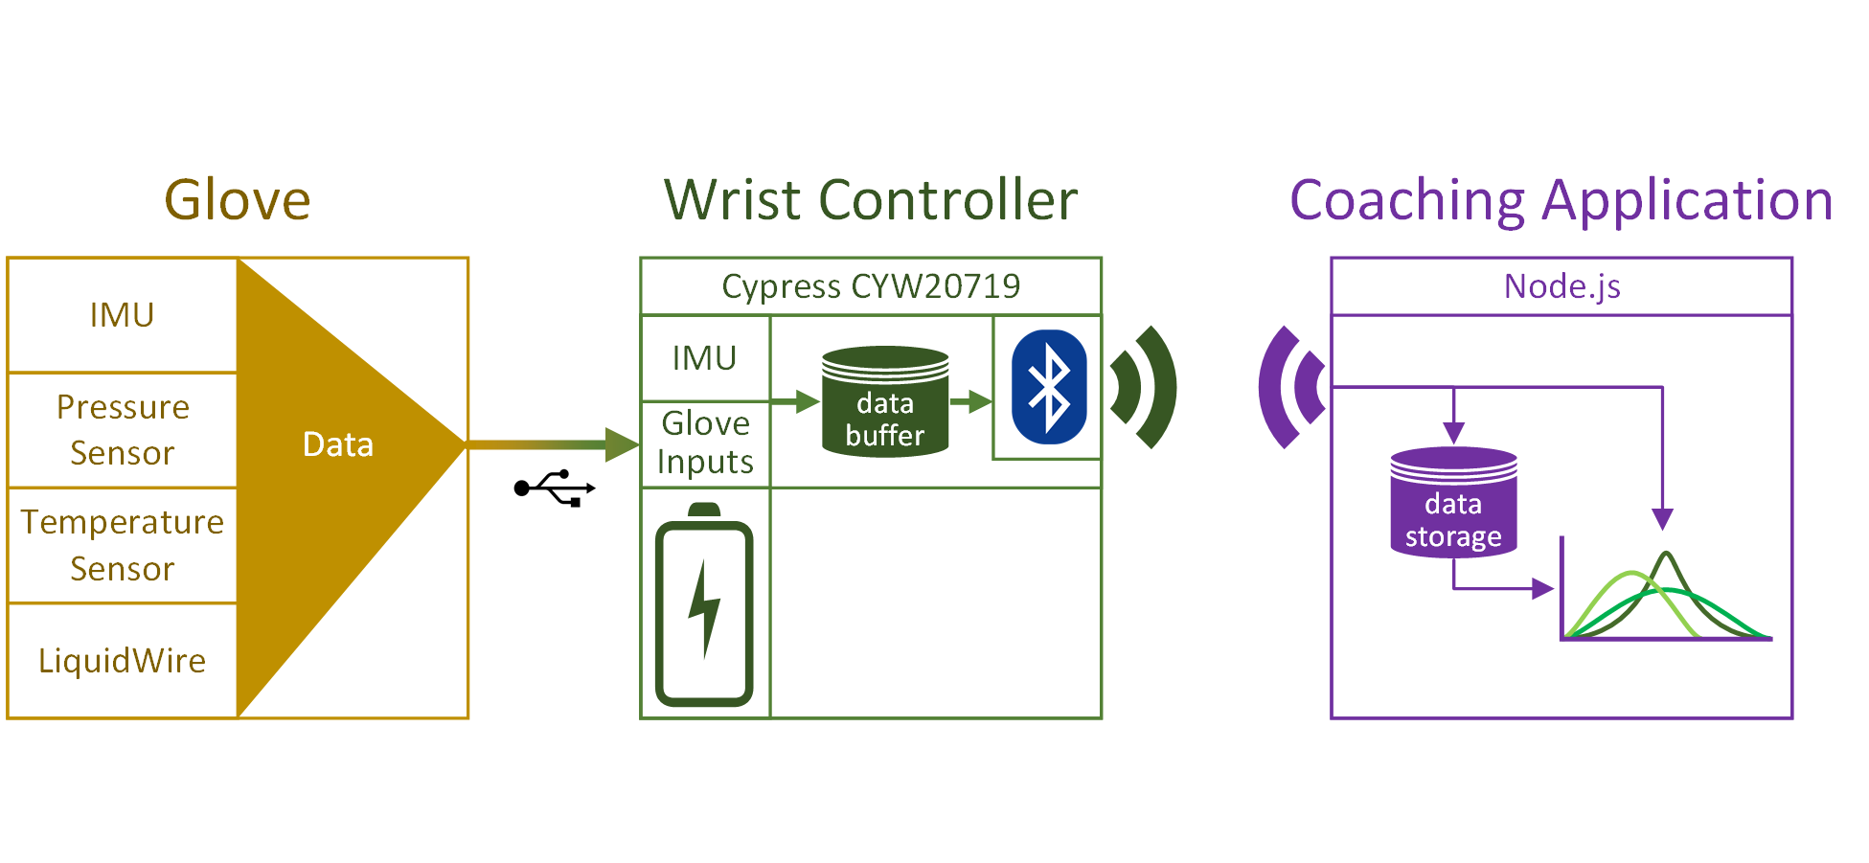

November 28, 2017

Prepared by:

C. Bush, S. Callicott, W. Carroll, L. Casey, J. Fletcher

Faculty Advisor: Professor John Ball

Department of Electrical and Computer Engineering

Mississippi State University

413 Hardy Road, Box 9571

Mississippi State, Mississippi 39762

email: {cbb330, sc2257, woc17, lec426, jdf469}@msstate.edu



**LIST OF ABBREVIATIONS**

ADC - Analog Digital Converter

BLE - Bluetooth Low Energy

EMR - Electromagnetic Radiation

GATT - Generic Attribute

GUI - Graphical User Interface

I2C - Inter-Integrated Circuit

ICNIRP - International Commission on Non-Ionizing Radiation

IDE - Integrated Development Environment

IEC - International Electrotechnical Commission

IMU - Inertial Measurement Unit

IP - Ingress Protection

RF - Radio Frequency

RoHS - Reduction of Hazardous Substances

RSSI - Received Signal Strength Indication

SAR - Specific Absorption Rate

**EXECUTIVE SUMMARY**

Golf Glove offers golfers a revolutionary way of tracking one’s golf swing. In contrast to other systems, the Golf Glove is low-profile and convenient. When on the course, golfers have no accurate way of recording swing technique on their own. The Golf Glove is a system that consists of multiple inertial, pressure, and flex sensors that can accurately track and record a golfer’s swing in real time. This gathered data is used to provide real time coaching feedback to the golfer. The system, depicted in Figure 1, is comprised of three subsystems: the glove garment, the wrist-mounted controller, and the coaching application.



Figure 1. Golf Glove System Architecture

The main constraints of the Golf Glove design include the wireless transmission speed and the resolution of the various measurement sensors. Additionally, the entire system must be able to fit onto a standard golf glove and connect to a wrist-mounted controller that is no wider than a standard sweatband (3”). The Golf Glove will typically be used in outdoor environments; therefore, the system must be able to handle realistic environments with protections against water and dust ingression as well as moderate temperature conditions. Finally, the wrist-mounted controller must be battery powered and communicate wirelessly to the coaching application across 10 meters, the length of an average golf tee box.

The Golf Glove system contains a controller to record sensor data. Its array of sensors includes two accelerometers to track swing movement, two pressure sensors to read grip pressure, and four LiquidWire stretch sensors to measure wrist angle. Finally, a battery will be integrated to continuously power the device for at least 5 hours. The system uses a novel stretch sensor technology developed by LiquidWireto track the flexion and deviation of the wrist. LiquidWire sensors were chosen due to their ability to be sewn into the glove itself while being able to stretch without inhibiting function. The Golf Glove communicates via Bluetooth Low Energy to send packets containing the user’s swing data to the coaching application.

Golf Glove improves on existing systems by shrinking the system size and by adding the capability to track wrist movement via flexible sensors. Future improvements to the system may include 3D rendering of the user’s swing and generating intelligent feedback based on gathered data. Golf Glove provides an affordable and comprehensive solution by combining stretch sensors with the motion and pressure sensing capabilities of products currently on the market.

TABLE OF CONTENTS

4. EVALUATION 6

4.1. Glove Subsystem 6

4.1.1. Accelerometer 6

4.1.2. Gyroscope 7

4.1.3. LiquidWire 7

4.1.4. Pressure Sensor 8

4.2. Wrist-mounted Microcontroller Subsystem 9

4.2.1. Battery 9

4.2.2. Sensor Polling 10

4.2.3. Bluetooth Broadcast 10

4.2.4. Hardware Footprint 11

4.3. Coaching Application Subsystem 12

4.3.1. Bluetooth Reception 12

4.3.2. Database 12

4.3.3. WebSocket Bandwidth 13

4.4. Integrated System 13

5. SUMMARY AND FUTURE WORK 15

5.1. Hardware 15

5.2. Microcontroller 16

5.3. Coaching Application 16

5.4. Future Features 16

6. ACKNOWLEDGEMENTS 16

7. REFERENCES 17

8. APPENDIX: PRODUCT SPECIFICATION 20

# PROBLEM STATEMENT

## Historical Introduction

The game of golf originated in the Middle Ages. It began with simple wooden clubs and leather balls in Scotland, and spread internationally through Great Britain’s colonial conquests [1]. Throughout the 1900s, golf became a household sport, and players began wielding advanced equipment because of increasing interest in the sport and technical innovation. In addition, the thirst for improvement was pervasive, evidenced by some of the earliest film showcasing golf experts and their swings. Clearly, players have an innate drive to improve their performance and are willing to invest money for an advantage on the course.

Analysis of the golf swing has improved dramatically over the past few decades. As early as 1985, new technologies became available, allowing kinesiologists to analyze their subjects’ swings using a combination of phase-locked cameras and digital algorithms to determine the torque on a golfer’s joints [2]. Much more recently, the explosion of small, inexpensive electronics made swing analysis technology affordable, bringing it out of the research lab and into the average player’s hands.

Modern data analytics and smartphone technology continue to revolutionize golf. Today’s golfers can receive personalized, on-course training and information through smartphone applications. Bluetooth-connected sensors measure acceleration and position data during a swing, relaying the position data of a swing wirelessly to the application. The Golf Glove records more elements of a swing by using additional sensors to measure hand movement and articulation, providing even more-detailed data for coaches and analytical software. By combining inertial, pressure, and wrist-angle data, Golf Glove aims to provide a user with the most comprehensive record of each swing.

## Market and Competitive Product Analysis

The Golf Glove targets tech-savvy golfers who do not want to spend money on a coach and is designed to be a cost-effective method for recording information on golf technique. On average, golfers spend $2,776 annually on golfing-related expenses [3]. The Golf Glove is marketed specifically toward enthusiasts who want to improve their swing. Comparatively, large driving ranges such as Top Golf service millions of new members across the United States every year. With an average customer spending $35 per visit, Top Golf could could integrate the Golf Glove into their system to give customers feedback on their swing technique [4]. Customers could rent the glove for a small fee and use it during their visit.

Several other systems on the market can track a player’s hand and club movement, but none of these systems track wrist movement. The Garmin TruSwing and Skypro both cost $150, clip onto a golfer’s club, and track club movement via of accelerometers and gyroscopes. Other systems involve screwing in sensors to the top of a golfer’s club and cost around $16 per sensor [5]. These systems only focus on a golfer’s club movement using a club-mounted gyroscope and accelerometer; they ignore important biomechanical data. The Golf Glove is designed to offer more useful data at or below the price of these inferior systems on the market. Rather than solely tracking the velocity of the golf club, the Golf Glove integrates flexible sensors that track biomechanical data of wrist inflection, rotation, and grip pressure. By tracking this data, the golfer can look back on areas where their swing needs improvement. Additionally, the Golf Glove is designed to reduce the risk of wrist and elbow injuries by encouraging proper swing technique through data feedback.

## Concise Problem Statement

Golf swing training tools currently on the market are either prohibitively expensive. For instance, Swinguru service which offers 1-year subscriptions to 3D golf analysis software at a rate of $1199.00 [40]. Meanwhile, a professional coaching session may look at club movement, but these sessions are similarly expensive and users must pay for each session separately.

The Golf Glove is designed to be an affordable and reusable solution to these issues. Utilizing an array of sensors, the glove will track the hand and arm biomechanics that control the golf swing. The data that these sensors collect will be analyzed and used to give training feedback to the user. Instead of showing the user their swing based on poor club movement, the product will show the user the more in-depth causes of their swing problems: poor biomechanics. The Golf Glove is a wireless system that can be paired to any smart device or computer using a downloadable application.

## Implications of Success

The Golf Glove provides a training tool to track and analyze swing technique at an affordable price. It unlocks the benefits of data-driven training for a significant population. The system captures and analyzes swing data to provide feedback to the user, helping them to understand the flaws in their swing. Correcting these flaws will improve the user’s golf swing and bring consistency to their overall golf game.

Additionally, the Golf Glove could improve the professional market by assisting swing coaches. Specifically, the Golf Glove simplifies benchmarking and tracking player improvement by attaching raw data to a swing. The precision of the device will also help swing coaches locate small inconsistencies in a player’s swing that might otherwise be overlooked.

The functionality that the Golf Glove provides could revolutionize golf swing training. By collecting swing data and evaluating it for form correctness, the Golf Glove can suggest improvements to the golfer. Taking this training feedback into account, a golfer is able to take steps to improve their swing mechanics. By learning to striking the ball with proper mechanics, users will be able to consistently record improvements in their rounds of golf.

# DESIGN REQUIREMENTS/CONSTRAINTS

The Golf Glove must have an unobtrusive design that incorporates accurate stretch and orientation sensors. These sensors are crucial to the product’s goal of accurately measuring hand movement that will be displayed to the user. The design must consist of three subsystems: the garment with integrated sensors, the wrist-mounted controller, and the coaching software. The garment must measure the user’s hand orientation, hand velocity, and wrist motion via integrated sensors and pass these metrics to the wrist-mounted controller. The wrist-mounted controller must then broadcast the swing data to a coaching application, which will display the data giving the user valuable insight into their swing. Additionally, Golf Glove must adhere to the three engineering standards outlined in Table 2.3. Specifically, the design must be IP54 rated, not include materials listed in the RoHS directive, and also maintain EMF levels lower than the ICNIRP permits for wearable technology. The design must conform to the following technical and practical design constraints and the listed engineering standards to achieve the expected functionality and appeal to the user.

## Technical Design Constraints

The Golf Glove must collect data, incorporate a real-time data display, and prioritize usability. Table 2.1 identifies five constraints for the system’s technical performance that will be further detailed in their respective subsections. The device must meet these constraints to ensure accurate and reliable function.

Table 2.1. Technical Design Constraints

|  |  |
| --- | --- |
| **Name** | **Description** |
| Hand Orientation | The glove must determine the angles of wrist flexion, extension, and deviation within a ±3° margin of error. Also, the glove must measure wrist acceleration, hand orientation, and hand acceleration within a ±5% margin of error. |
| Wireless Communication | The wrist-mounted controller must communicate wirelessly with a range that will span the average width of a tee box: 9.15 m. |
| Data Display | The data is recorded at 120 Hz and can analyzed in real-time. |
| Unobtrusive | The user must not be obstructed while gripping the club with the glove on. The wrist-mounted controller must have a footprint smaller than the average sweat-band size of 7.62 cm. The sensor wires in the glove must not interfere with swing motion. |
| Portability | The battery life of the wrist-mounted controller must exceed 5 hours of use. |

### Hand Orientation

The Golf Glove must measure forearm, wrist, and hand orientation to within a 3° margin of error and hand velocity within a 5% margin of error. The standard shaft length for a driver golf club is 1.1 m [6]. Using this measurement, a 3° rotation of the wrist amounts to a 5.8 cm movement of the club head, which allows the club head location to be estimated to within one-half of its length [7]. The average golfer’s swing speed is about 32 m/s, meaning a 5% margin of error in hand velocity will measure the swing speed to within 1.2 m/s [8].

### Wireless Communication

The Golf Glove must maintain a connection with the data display up to a maximum distance of 9.15 m. According to Jeff Brauer, a columnist for Golf Course Industry, tee box dimensions vary due to number of expected players. He states that the white tee box, the most common tee box to start from, can be between 9.15 and 13.7 m in width [9]. Given that most players tee their ball in the middle-third of the box, a maximum wireless distance of 9.15 m is more than comfortable for the average user. Conforming to this constraint enables the product to be fully operational without keeping a computer device on their person. Users can store mobile devices nearby, such as in the user’s pocket or in a golf cart, while still connected. In the event of a dropped wireless connection, the Golf Glove must be able to store several golf swings in memory until the connection is reestablished.

### Data Display

The Golf Glove must transmit data to a computer application at a rate of 120 Hz and display the measured data in real-time. A display application is necessary to show the gathered data to the user in addition to providing feedback. The display must incorporate graphs to show hand pressure, acceleration, and rotation as well as wrist flexion and extension over time. A real-time data display allows the user to practice certain key postures during the swing and ensure that their wrist angles and positions are correct.

### Unobtrusive

Since the target audience includes both professional and recreational golfers, the Golf Glove must be as unobtrusive to the golfer’s swing performance as possible. The average width of a human hand is 7.94 cm [10]. Therefore, to ensure the device doesn’t push against the edges of the glove, its footprint must be less than 4 cm in length and width.

Also, the wrist housing must not impede wrist flexion and extension so the user can maintain a full range of motion. The two main factors for the size of the wrist controller are band width and circumference. The band’s width must be smaller than 7.62 cm: the width of a common sweat band. The circumference must be adjustable from 14 cm to 23 cm to accommodate an average range of wrist sizes [11].

### Portability

To prevent the user from being tethered to a stationary power source, the device must incorporate a battery system. The garment and controller system must fit in a user’s golf bag pocket, allowing the user to easily bring the device onto the golf course without a separate carrying case or bag. An onboard rechargeable battery provides enough power to complete a 5-hour golf game and removes the need to carry around replacement batteries or obtrusive power cables. This time constraint will ensure the device is operational throughout an average 18-hole round of golf [13]. The power system must contain a protection circuit to prevent overcharge, overdischarge, and short-circuit situations. Overdischarge occurs when the user forgets to turn the device off and results in a permanently damaged battery. Overcharge occurs in the event of a charger malfunction and can cause rapid thermal discharge of the battery. Overcharge and overdischarge are characterized by the battery reaching a voltage over 4.2 V or under 3.0 V, respectively [14]. Lastly, short circuits occur in the event of corrosion and may cause damage to the circuit itself. The battery must charge in under 2 hours so that the user could theoretically charge it during their free time during lunch or between individual golf holes.

## Practical Design Constraints

Table 2.2 details the practical design constraints for the glove design: economic, environmental, health and safety, manufacturability, and sustainability. Adhering to these constraints will create a low-cost solution that is suited to a golf environment and ultimately values ease of use.

Table 2.2. Practical Design Constraints

|  |  |  |
| --- | --- | --- |
| **Type** | **Name** | **Description** |
| Economic | Cost | The Golf Glove must cost less than $200. |
| Environmental | Weather-Resistant | The glove must be IP54 water and dust resistant. |
| Health and Safety | Swing Form | The glove must notify the user of proper swing form which helps prevent body stress and injury. |
| Manufacturability | Modular/Replaceable Parts | The garment and controller must be modular by allowing the glove and wrist-mounted controller to be  interchangeable if a subsystem fails. |
| Sustainability | Reusability, Safety, and Rechargeability | The glove garment must be reusable and rewashable. The battery must recharge within 2 hours. |

### Economic

The total cost of the sensor glove and controller must be under $200 to make the Golf Glove competitive with other products on the market. Additionally, the glove component must be separate from the controller to make either part replaceable for a lower cost than replacing the entire device.

### Environmental

Due to the need for sustained use in potentially wet or dusty environments, the Golf Glove’s design must conform to the Ingress Protection (IP) 54 standard. The functionality of the device must be unaffected by dust accumulation and water sprays.

### Health and Safety

The Golf Glove must not harm the user during normal operation. The main objective for the device is to promote proper swing technique; this includes indicating and correcting improper and harmful form. For example, gripping the golf club too hard with the ulnar aspect of the palm during a swing can result in elbow injuries [12]. The glove will measure pressure on the ulnar and radial halves of the palm so that the user can be notified when they are using too much pressure on the club with the wrong fingers. Promoting proper technique will result in fewer unnecessary injuries.

### Manufacturability

The design must incorporate efficient use of modern, easily-sourced components wherever possible. Therefore, Golf Glove must use components that have large amounts of community and manufacturer support. The glove and wrist-mounted controller must be modular to allow the user to replace either piece without having to replace the other. A standard connector will link the glove and wrist-mounted controller, allowing either component to be interchangeable. In the event of a depleted battery, the system must account for replacement to reduce waste and allow for prolonged system use. The components and housing must allow for efficient assembly on a production line through use of human workers or robotic pick-and-place machines.

### Sustainability

The Golf Glove must be designed as a reusable training aid. The garment must be machine-washable as it may become dirty after use. Also, the battery must be rechargeable to reduce waste. Not only is prioritizing sustainability responsible, it also improves the user experience.

## Appropriate Engineering Standards

The engineering standards identified in Table 2.3 target the environmental and health and safety constraints for the device.

Table 2.3. Appropriate Engineering Standards

|  |  |  |
| --- | --- | --- |
| **Specific Standard** | **Standard Document** | **Specification/Application** |
| IP54 | EN 60529 | Rule 5 for dust protection states that the dust quantity allowed to enter or deposit does not impact the proper function of the system. Rule 4 for water protection states that water sprayed from any direction against the machine must not cause damage [15]. |
| Restriction of Hazardous Substances Compliance | RoHS-1 | The device must not contain substances banned under RoHS [16]. |
| ICNIRP High Frequency EMR Guidelines | ICNIRP | Whole body and local body specific absorption rate due to human exposure to RF fields from wireless devices must not exceed certain levels [17]. |

### Environmental

The device must adhere to the IP54 standard. Defined in Table 2.3, the IP54 standard qualifies the dust and water ingress to the device. IP54 provides a sufficient level of protection from both dust and water, which are two environmental factors that golfers often face. The standard states that while water and dust may interact with the device, the device operation must not be harmed [15].

### Environmental Materials

The device must be RoHS compliant. RoHS details several hazardous materials that should not be used in consumer products due to health issues from extended exposure. To achieve compliance, the design must not contain any of the materials listed so that the device will not result in excess pollution when discarded or cause harm to the user. RoHS is defined in depth throughout Directive 2002/95/EC of The European Parliament [18].

### Health and Safety

The device must conform to the International Commission on Non-Ionizing Radiation Protection (ICNIRP) standards for limiting exposure to electromagnetic radiation (EMR) fields. To achieve this, the device radiation will be measured with International Electrotechnical Commission (IEC) 62209 which defines standards surrounding the specific absorption rate (SAR) due to human interaction with radio frequency (RF) EMR [17]. Following the ICNIRP threshold of General Public Exposure for mobile devices, the device’s whole-body SAR rating must not exceed 0.8 W/kg and local-body SAR rating must not be above 4 W/kg [19].

# APPROACH

This section details the approach to satisfying the technical and practical constraints required for successful implementation. The design is comprised of three distinct subsystems: a glove garment, a wrist-mounted controller, and a coaching application. The glove subsystem will include stretch sensors, pressure sensors, and inertial measurement units (IMU). This collection of inputs will be physically connected to a battery-powered, wrist-mounted controller that samples the sensor inputs. Sampled data will be transmitted to the coaching application, stored in a persistent database, analyzed, and displayed to provide golf swing feedback to the user. Figure 3.1 is a functional diagram of the glove, wrist-mounted controller, and coaching application subsystems.



Figure 3.1. System Overview

## Hardware

The hardware chosen for the glove and wrist-mounted controller is essential in ensuring accurate measurement and a 120 Hz wireless data rate. In this section, critical hardware components are compared and optimal candidates are selected for the final design.

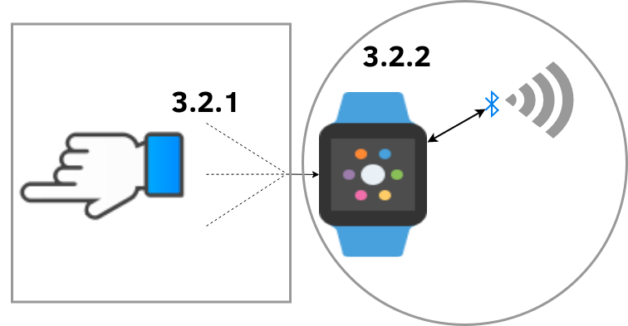

Figure 3.2. Hardware Subsystems

### Glove

The glove subsystem consists of the glove garment, linear stretch sensors, flexible pressure sensors, an IMU, and electrical connector components. This garment functions as a mounting surface for the various sensors. These sensors will receive power and transfer data to the controller through the electrical connector mounted on the glove.

#### Glove Garment

The glove garment is the mounting point for all of the linear stretch sensors, an IMU, and pressure sensors. A connector will also be mounted on the glove to connect to the controller, making the glove and controller exchangeable. For the initial prototype, two sizes of gloves will be created to fit different golfer’s hand sizes comfortably. The glove will be constructed out of leather, a common material used in golf gloves.

#### Linear Stretch Sensors

The linear stretch sensors are crucial to the Golf Glove design to measure wrist angles. These sensors vary linearly in either resistance or capacitance as the sensor stretches and typically consist of an elastic material fused with a flexible resistive material or capacitive shape. The linear stretch sensors must measure wrist angle to within ±3° margin of error to satisfy the Hand Orientation design constraint.

Two brands of linear stretch sensors were considered: LiquidWire and StretchSense. LiquidWire was ultimately chosen because of its resistive variability and low cost. StretchSense evaluation kits cost $2050 with no discounts for product development [41]. Additionally, measuring resistance with a microcontroller requires a simpler circuit than measuring capacitance.

As LiquidWire sensors are available in custom lengths, the design will use a length of 11.5 cm for development. Upon examining the natural bend of the hand, the maximum required stretch length of a sensor is approximately 2.5 cm. LiquidWire rates their sensors to stretch up to 125% of their resting length without damaging the sensor; thus, a resting length of 11.5 cm was selected [20]. The resting resistance of each sensor is approximately 50 Ω; however, the resistive value may vary slightly due to LiquidWire’s manufacturing process. As a result, a calibration procedure will be required for each sensor. A test of the sensors shows a typical resistive increase of 3 Ω at full stretch.

#### Flexible Pressure Sensors

The Golf Glove must record the force of the user’s hand on the golf club accurately in an unobtrusive manner. Therefore, the design will use two flexible pressure sensors to detect the force in two locations on the palm of the hand. Having two measurement locations allows the device to analyze the user’s distribution of force on the golf club. Per the design constraints, these measurements will be used to discourage improper swing form that increases injuries such as tennis elbow.

A study found that maximum human grip strength reaches a value of 539 N. A reasonable golf club grip will not exceed this maximum range as it peaks at a value of 98 N [21, 22]. Thus, a sensor with a maximum pressure sensing ability of 245 N is appropriate. Sensor size must be within half an inch in diameter to not impede user mobility during a swing. Table 3.1 shows possible pressure sensors that satisfy this 245 N requirement.

Table 3.1. Flexible Pressure Sensor Comparison

|  |  |  |  |  |
| --- | --- | --- | --- | --- |
| **Name** | **Diameter**  **(mm)** | **Price**  **(USD)** | **Resistance Range**  **(Ω)** | **Interface/Communication** |
| Interlink 400 Series [23] | <15 | 7.00 | Infinite-250 | Analog |
| Velostat Conductive  Sheet [24] | Custom Sheet | 3.95 | Variable | Analog |

The Interlink 400 series of resistive pressure sensors was chosen due to the simplicity of their integration into the garment. These flexible sensors can be bent 90° without damage and are manufactured with tinned contacts that allow for a direct connection to the glove connector. While the Velostat conductive sheet would need to be manufactured to specification, the Interlink 400 series sensors are already adequate. Thus, there is no need to cut or measure each sensor for each glove and the resistance value can be set in the device firmware as a constant value. Additionally, while the price of materials per sensor is higher for Interlink sensors, using them drastically improves the manufacturability of the Golf Glove because the sensors to not need to be manufactured.

#### Electrical Connector

The electrical connection between the glove’s sensors and the wrist-mounted controller should be robust and capable of handling multiple sensor inputs and outputs. By counting the amount of sensor channels and voltage inputs/outputs, it was determined that a minimum of eight conductors would be necessary. Specifically, the design will have two conductors for I2C communication, four conductors for stretch sensors, and two conductors for pressure sensors. Rather than create a proprietary connector and thereby compromise the Manufacturability constraint, the design will use a standardized connector. Table 3.2 shows a comparison of potential connector standards.

Table 3.2. Standard Connection Comparison

|  |  |  |  |
| --- | --- | --- | --- |
| **Standard** | **Number of**  **Connections** | **Reversible** | **Max Power**  **(A)** |
| USB-C | 12 | Yes | 5 |
| USB-Micro | 5 | No | 5 |
| Cat-5 | 8 | No | 0.63 |

The design will use a standard USB-C connector to connect the glove sensors and the wrist-mounted controller. USB-C can provide more than enough current to the sensors and contains a sufficient number of pins to transfer data to the wrist-mounted controller. Also, a USB-C connector is  reversible, which removes possible confusion and frustration associated with irreversible connectors.

### Wrist-Mounted Controller

The wrist-mounted controller containsan IMU, a microcontroller, and a battery. The wrist-mounted controller is responsible for collecting and transmitting data to the coaching application. This section compares the design options considered for these components.

#### Inertial Measurement Unit

The Golf Glove requires two IMUs—one in the wrist-mounted controller and one on the back of the hand—to accurately measure movement according to the constraint of wrist acceleration, hand orientation, and hand acceleration within a 5% margin of error. These IMUs will measure acceleration of the hand and the rotation of the wrist. A typical golf swing involves linear acceleration of up to 1.5 g and rotational speeds of up to 1000 degrees per second at the wrist [25, 26]. Table 3.3 provides a comparison of the considered IMUs.

Table 3.3. Inertial Measurement Unit Comparison

|  |  |  |  |  |  |
| --- | --- | --- | --- | --- | --- |
| **IMU** | **Cost (USD)** | **Power Draw (mA)** | **Accelerometer (g-force)** | **Gyroscope (degrees per sec)** | **Output Resolution/Rate** |
| STM LSM9DS1 [27] | $ 6.14 | 1.9–3.6 | ±2/±4/±8/±16 | ±245/±500/±2000 | 16-bit @ 1 kHz |
| Bosch BMX055 [28] | $ 7.02 | 2.4–3.6 | ±2/±4/±8/±16 | ±125 to ±2000 | 16-bit @ 1 kHz |
| mCube MC6470 [29] | $ 3.01 | 0.07–1.0 | ±2/±4/±8/±16 | 500 (Interpolated) | 14-bit @ 0.1 kHz |

The design constraints specify a minimum sampling rate for sensor data of 120 Hz; this immediately eliminates the mCube IMU device due to its maximum sampling rate of 120 Hz. The Bosch and STM devices have comparable inertial measurement capabilities with selectable 2 g, 4 g, 8 g, or 16 g acceleration modes and similarly selectable range of rotational speed modes. The selectable modes define the minimum and maximum thresholds of the measurements; a lower acceleration or rotational speed setting allows the device to measure with more precision. The most precise modes of the accelerometer and gyroscope support measurement accuracy to 0.0006 g and 0.004 degrees per second respectively, which satisfies the Hand Orientation constraint. Because both device choices offer nearly identical measurement and output modes, the STM LSM9DS1 was selected due to its lower price and smaller power draw during sleep mode. Additionally, the LSM9DS1 device is widely used in many hobbyist and professional projects and comes with a well-tested set of open source libraries for interfacing.

#### Microcontroller

The design requires a low-power, wireless-enabled microcontroller because of its constraints for wireless communication, portability, and sustainability. Table 3.4 compares the microcontrollers considered for the Golf Glove design.

Table 3.4. Microcontroller Comparison

|  |  |  |  |  |  |
| --- | --- | --- | --- | --- | --- |
| **Microcontroller** | **Cost (USD)** | **Wireless Connectivity** | **Power Draw (mA)** | **Flash Memory (kB)** | **ADC** |
| Cypress CYW20719 [30] | $ 9.63 | BR/EDR/BLE Bluetooth 5.0 @ 2 Mbps | 10 mA | 1024 | 1 x28-channel, 10-bit, 3.6 ksps |
| Microchip IS1871 [31] | $ 2.98 | BLE Bluetooth 5.0 | 8 mA | 256 | 1 x6-channel |

The Cypress CYW20719 was selected because it contains a radio capable of Bluetooth Low Energy (BLE) communication and has 10 Analog to Digital Converters (ADC). The Microchip device was not available in North America at the time of this decision and it does not have a user-friendly development environment. Cypress provides WICED, a featured and free integrated development environment (IDE) for use with the microcontroller. The CYW20719 has a complete Bluetooth stack on-board, and Cypress has released several development and Bluetooth debugging tools specifically for the CYW line of products. Based on these factors, the CYW20719 is the more suitable choice for the design.

#### Radio

The Golf Glove will use the CYW20719’s built-in Bluetooth 5.0 radio for wireless communication, avoiding the need to add and interface with an external communication system. This decision is driven by concern for the final size of the system. By utilizing the built-in radio, the device’s size and cost are minimized.

To satisfy the design constraints, the design requires an internal radio system with low power consumption while being capable of adequate and consistent communication throughput. The integrated BLE 5.0 stack offers a host of benefits over other systems such as infrared transmission or Wi-Fi. While infrared systems consume a small amount of power, the connection is intermittent. Wi-Fi systems face the opposite problem; their transmission distance and reliability are excellent, but their power consumption is comparatively large. The chosen protocols, BLE paired with the Generic Attribute (GATT) application layer, satisfy both the power and data throughput constraints.

#### Power Requirements

The Portability constraint requires the Golf Glove to be a battery-powered system that remains operational for a minimum of five hours. The values in Table 3.5 describe the quantity and power usage of each of the components operating at 3.3 V. The estimated minimum power usage is calculated in the Total Power Usage equation below to determine the required battery capacity. The specific power-consuming components included in the calculation are the I/O pins, the internal Bluetooth module, and the two IMUs. By summing the power usage of each device, it was determined that a 500 mAh battery would be sufficient for the design to satisfy its constraints. Additional considerations for the battery selection were rechargeability and form factor.

Table 3.5. Power Usage Calculations

|  |  |  |  |  |
| --- | --- | --- | --- | --- |
| **Device/Subsystem** | **Max Power (mA)** | **Quantity Needed** | **Hours of Use** | **Power Usage (mAh)** |
| I/O Pins | 16 | 4 | 5 | 320 |
| Radio RX/TX | 11.5 | 1 | 5 | 57.5 |
| IMU | 4.6 | 2 | 5 | 46 |
| Microcontroller | 3 | 1 | 5 | 15 |

**Total Power Usage:** (I/O pins) + (Radio) + (IMUs**) +** (Micro) =320 mAh + 57.5 mAh + 46 mAh + 15 = **438.5 mAh**

**Power Conservation Usage:** (Radio) + (Micro) **=** 57.5 mAh + 15 mAh = **72.5 mAh**

Table 3.5 shows that the average current draw over 5 hours is 87.7 mA. The power usage calculation above does not consider sleep functionality; it is a worst-case scenario to determine the minimum battery requirements. Given the above calculation, the battery should contain a minimum capacity of 500 mAh. The microcontroller has the ability to turn off its I/O pins, operating in a power conservation mode. By using this power conservation mode, whose power consumption is calculated in the Power Conservation Usage equation above, the device can remove I/O and IMU power consumption, increasing the battery life. Table 3.6 displays a comparison of battery options.

Table 3.6. Battery Choices

|  |  |  |  |  |  |  |
| --- | --- | --- | --- | --- | --- | --- |
| **Component (Battery)** | **Price (USD)** | **Capacity (mAh)** | **Output Voltage (V)** | **Form**  **Factor** | **Chemical Composition** | **Rechargeable** |
| LP503035 [32] | 1.00 | 500 | 3.7 | Pouch Cell | Li-Ion Polymer | Yes |
| UxCell AAA [33] | 1.64 | 500 | 1.2 | AAA Cylinder | Ni-MH | Yes |
| Duracell AAA [34] | 0.55 | 541 | 1.5 | AAA Cylinder | Alkaline | No |
| Panasonic CR3032 [35] | 2.45 | 500 | 3.0 | Coin Cell | Lithium | No |

The LP503035 was selected as the power source for the design. The battery is rechargeable and is sufficiently capacious to power the Golf Glove for 5 hours. The battery output will be clamped to 3.3 V using a buck/boost converter. The average output of  the LP503035, 3.7 V, will allow for efficient power conversion due to the low voltage difference. The LP503035 also contains an on-board voltage protection circuit that will prevent the battery from charging above 4.2 V and discharging below 3.0 V.

## Software

The design requires two pieces of software: one for the wrist-mounted controller and one for the coaching application. The wrist-mounted controller will collect data from the glove’s various sensors and then package and transmit that data via Bluetooth to the coaching application. Upon reception of the data, the coaching application will process, store, and display it. The coaching application’s logic will be split in two. The backend application will be responsible for handling the Bluetooth connection, processing data, and storing data. The frontend application will render graphical user interface of visual components from the data received by the backend. Because the coaching application software will be split into backend and frontend roles, the approaches of each role are discussed in seperate sections.

### Wrist-Mounted Controller Firmware

The wrist-mounted controller firmware controls the sensing aspect of the design by handling swing detection and sensor data acquisition. The firmware will poll over I2C for the IMUs and ADCs that connect to the stretch sensors. Each IMU will produce three gyroscope, accelerometer, and magnetometer measurements. Two pairs of opposing stretch sensors will measure two wrist angles. The ADC readings associated with stretch sensors will have a resolution of 16 bits.

The firmware will have two modes of recording sensor data. The first mode detects a swing using a swing detection algorithm. The data will be recorded at 120 Hz to produce a high resolution reading of swing movement. A swing is completed once the wrist-mounted controller measures below both an acceleration threshold and a pressure threshold. While recording, data will be written to a flash memory buffer to await Bluetooth transmission.

Sensor data may also be captured in a constant transmission mode where swing detection is disabled and sensor values are transmitted to the coaching application immediately. This mode will be useful to see sensor data while practicing swing positioning without swing detection interfering with data collection. The coaching application will receive a stream of sensor data as it is measured.

#### Implementation

The wrist-mounted controller firmware will be developed in C using the Cypress WICED IDE. The code structure will consist of a main event loop that will sleep between sensor polls. While operating in swing detection mode, swings will be identified by a sudden change in pressure as well as accompanying change in acceleration reading. Once a swing is detected, the firmware begins recording sensor data. While recording, the microcontroller is checking for the swing end condition. Once the swing end condition is met, sensor data will no longer be written to the data buffer.

In mode two, the swing detection logic will be disabled and data will be communicated to the coaching software immediately. Sensor reading modes can be controlled from the coaching application via a real-time enable flag settable through the GATT interface.

#### Software Flow Diagram

The state flow diagram in Figure 3.3 models the three states of the microcontroller.

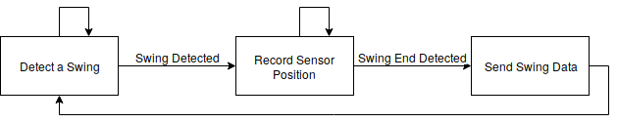

Figure 3.3. Firmware Stateflow Diagram

#### Interfacing

The wrist-mounted controller will interface with the coaching software via Bluetooth. Once the controller receives power, it will begin listening for a Bluetooth connection. Next, the coaching software will initiate a Bluetooth connection to the controller and pair the two so that data transfer can begin. After a connection is established, the controller will poll all sensors at a rate of 120 Hz and transmit this combination of sources as a single frame to the coaching application. The data frame will consist of an array of 56 bytes that stores every sensor reading for one polling interval. This array is further described in Table 3.7.

Table 3.7. Frame Protocol

|  |  |
| --- | --- |
| **Byte Index** | **Value** |
| 0-3 | Timestamp |
| 4-5 | Pressure Sensor 1 |
| 6-7 | Pressure Sensor 2 |
| 8-9 | Wrist Deflection |
| 10-11 | Wrist Extension |
| 12-13 | Radial Deviation |
| 14-15 | Ulnar Deviation |
| 16-33 | Wrist IMU |
| 34-51 | Hand IMU |
| 52-53 | Swing Synchronization |
| 54-55 | Data Availability |

### Coaching Software Backend

To facilitate the flow of swing data for analysis, the coaching application backend will receive a data frame from the wrist-mounted controller and subsequently process, store, and send it to the application’s frontend display. The structure of the data frame is described in Table 3.7.

As outlined in the Firmware approach section, the device will have two operating modes: real-time and swing-detection. The coaching application will be able to change the mode of operation via an option on the frontend. Figure 3.4 provides an overview of this subsystem with the chosen technologies.

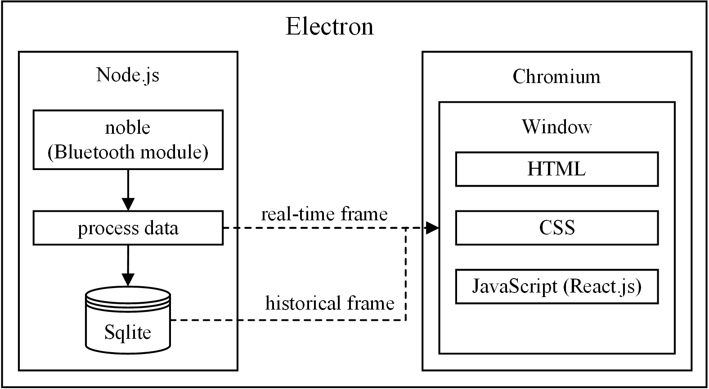

Figure 3.4. Coaching Application Software Overview

#### Implementation

The coaching software will receive data from the microcontroller via a BLE connection. For quick and efficient Bluetooth receiver development, the application will need to use a programming language with a library that has already implemented the Bluetooth protocol stack across the three major operating systems of Windows, OS X, and Linux. Taking into account the team’s prior experience, three programming languages—C++, Python, and JavaScript—were considered, with each having a few different Bluetooth libraries ranging in maturity and support. Although it is the most efficient of the three considerations, C++ was not chosen due to its slow development cycle and a lack of portability to the major operating systems, which would conflict with the design manufacturability constraint. Comparatively, Python development is quick and has frameworks for Windows, OS X, and Linux; however, the frameworks analyzed were neither mature nor supported by a substantial community. Fortunately, JavaScript met the search criteria of development speed, had documented Bluetooth platform compatibility, and had a very mature and actively maintained framework.

The coaching application will use Node.js, a JavaScript runtime environment, as the backend process host. For Bluetooth interfacing, the design will use the BLE framework *noble* [36]. *Noble* will handle all radio transmission overhead such as message length, error checking, and acknowledgements.

For both swing-detection and full-swing modes, data will be received as a stream into a buffer where a new timestamp in the buffer will delimit a new frame. Once this new frame is identified, it will be processed for storage and display. In full-swing mode, the frame will be deserialized as an object of a single swing’s data points; however, in real-time mode, a frame will be deserialized as a single data point. Deserializing all data members includes parsing the timestamp and the timestamp offset as well as converting the sensor data payload to decimal values. The coaching software will deduce and filter the frames that contain noise by measuring if their payload is outside an expected range. The expected range of values will be determined through testing once the prototype is complete.

Following the data frame parsing, the data will be stored in a SQLite database, which will be more than adequate for the application’s storage needs, and JavaScript has SQLite bindings in its standard library. If the device is operating in real-time mode, the application will also pass the parsed frame’s data directly to the display.

#### Interfacing

Node.js on the desktop will utilize the *noble* BLE library for interfacing to the microcontroller. It will first pair with the client, then always listen for incoming data. If the device is operating in real-time mode, the backend will receive frames containing single data points; in live-swing operating mode, it will instead receive a frame containing an array of the swing’s data frames. If the user changes the display mode, the backend application will transmit a message to the microcontroller indicating this change. Once acknowledged, the application will begin listening for new frames. Communication will occur using the GATT application layer protocol, which assigns metadata to each attribute that is used to describe the source of each sensor.

### Coaching Software Frontend

According to the constraints, the display must be simple and provide the user with the insight to improve golf swing technique. To accomplish this, each sensor’s signal will be overlayed on a graph over time. The user can toggle these graphs on or off to focus wrist movement, hand orientation, or hand velocity. The user will also have the option to zoom in on specific points in the swing. The display must also show real time and full swing graphing modes. For full-swing mode, the user will be able to choose between their most recent swing, or historical swings that are either show instantly or replayed. The Bluetooth pairing process will be exposed to the user through a settings view. The settings will also allow the user to show and manage memory filled with historical swings. Below in Figure 3.5 is a sketch of the display.

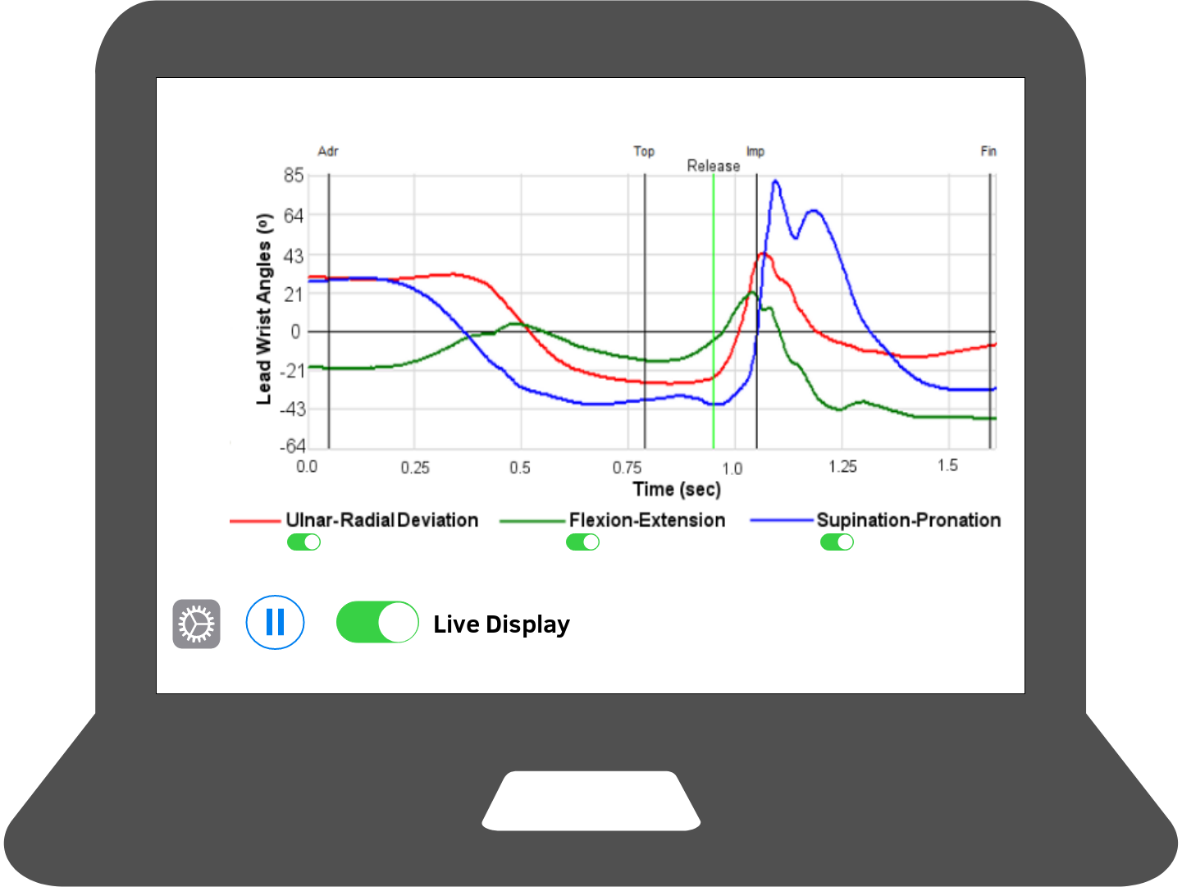

Figure 3.5. Mockup of Coaching Application Display

#### Implementation

For the GUI, there are three common options: a display in the web browser with AJAX, a display using Electron, or a GUI made in Python using the QT framework. A web browser has the advantage of being portable, as well as powered with JavaScript; however, it would require client/server communication overhead and extra development. A GUI in Python would also be portable and powerful, but the QT framework is not portable to mobile environments and would not satisfy the  manufacturability design constraint. On top of that, it would also require communication overhead between itself and the chosen *noble* library. The software will use an Electron application as it had all of the perks of the web page, but did not require client/server communication overhead and delay.

Electron is an open-source, cross-platform, desktop application framework that combines the Chromium browser rendering engine and Node.js [37]. Using the React framework inside Electron, the application will respond to both real-time display frames and full-swing display frames [38]. Real-time display frames will be instant measurements containing one data point, while full-swing display frames will be a combination of measurements contained in an array that represents a snapshot of the user’s whole swing. To accomplish the design constraint for display, these measurements will be displayed in graphs to the user to show hand pressure, hand acceleration, hand rotation, wrist flexion, and wrist extension over time. Figure 3.6 is a sketch of the display.

#### Interfacing

The display will receive sensor frames from the backend application using inter-process communication and the SQLite database. The display can query the database for historical swing values as well as receive updates from the backend server. Having both a persistent storage and event-driven updates allow the user to examine swing data live or at a later time.

### Software State Diagram

Figure 3.6 shows how the software application will function and conditions relevant to state changes.

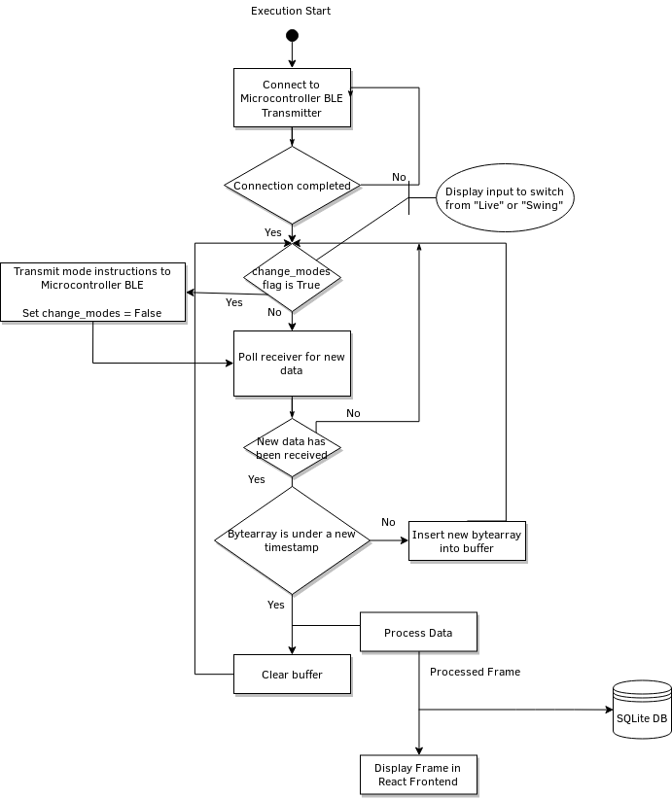

Figure 3.6. Software State Diagram

### Use Cases

Figures 3.7 and 3.8 describe the sunny and rainy day use cases for Golf Glove, respectively. Sunny day operation occurs when the wrist-mounted controller and the computer application connect properly.

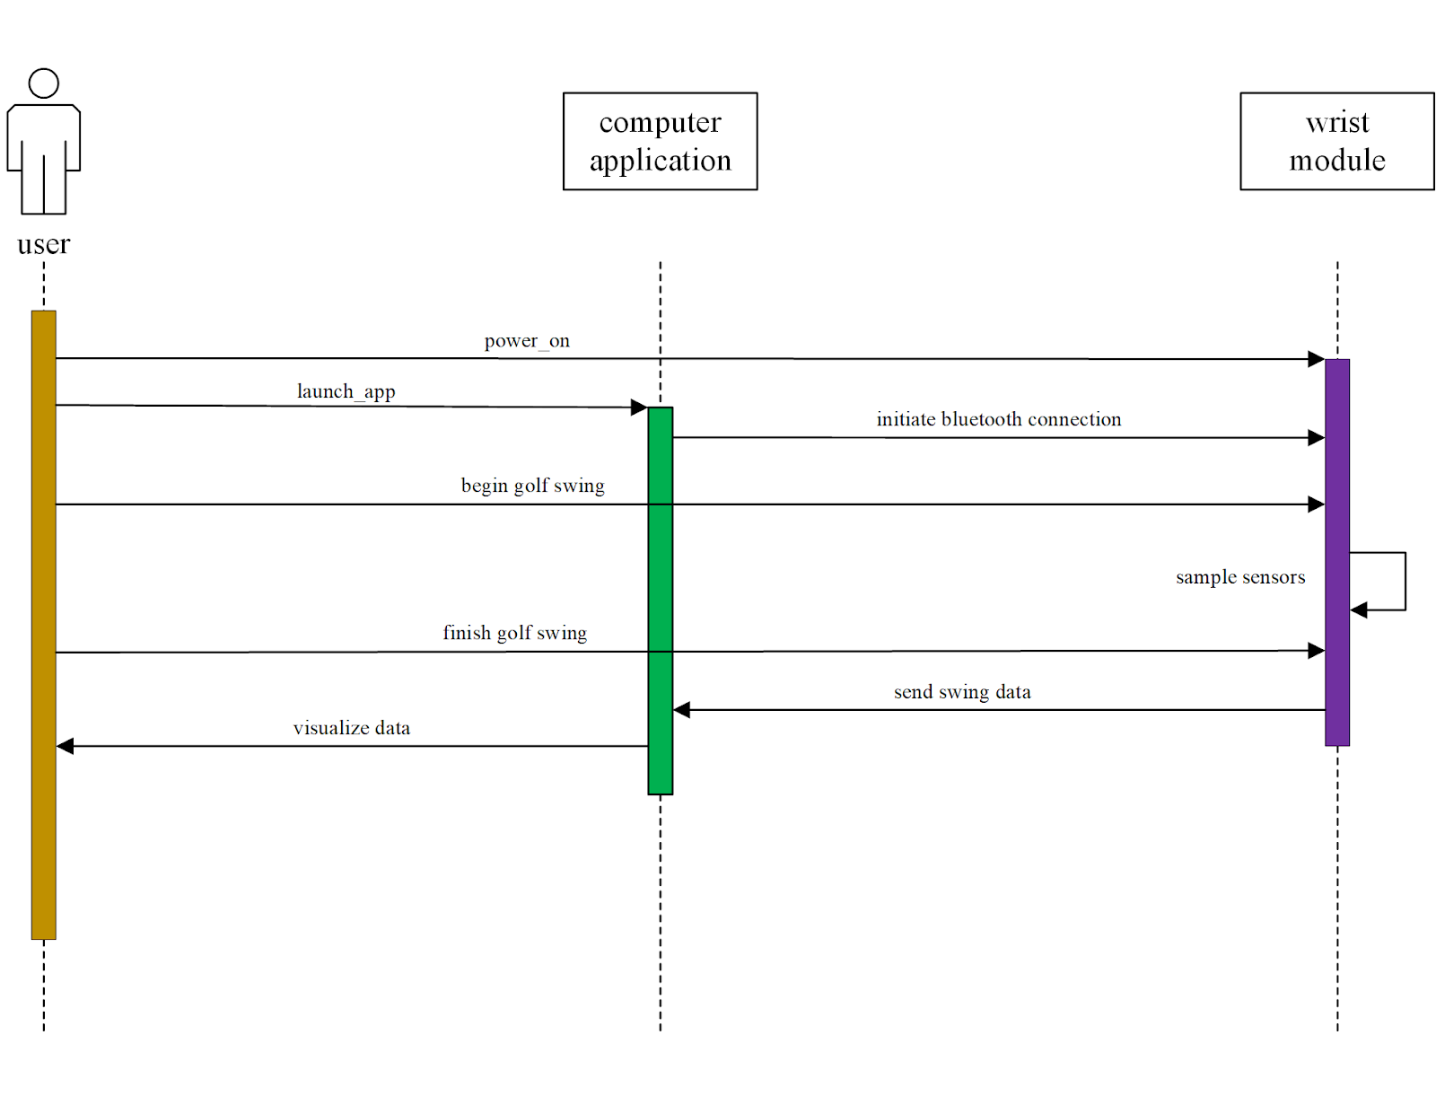Figure 3.7. Sunny Day Use Case

Rainy day operation occurs when the wrist-mounted controller does not have adequate charge to power on or the Bluetooth connection between the wrist-mounted controller and coaching application cannot be established.

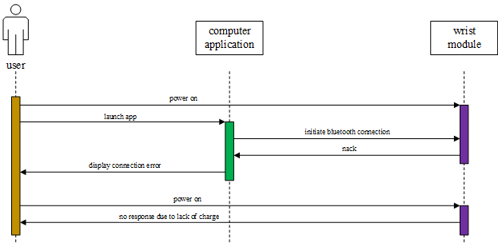

Figure 3.8 Rainy Day Use Case

# EVALUATION

The following section contains the results of the individual subsystem tests as well as a test of the integrated system. Each design constraint was explicitly considered when designing the individual tests. Table 4.1 contains the technical constraints that were tested.

Table 4.1. Technical Design Constraints

|  |  |
| --- | --- |
| **Name** | **Description** |
| Hand Orientation | The glove must determine the angles of wrist flexion, extension, and deviation within a ±3° margin of error. Also, the glove must measure wrist acceleration, hand orientation, and hand acceleration within a ±5% margin of error. |
| Wireless Communication | The wrist-mounted controller must communicate wirelessly with a range that will span the average width of a tee box: 9.15 m. |
| Data Display | The data is recorded and displayed at 120 Hz. |
| Unobtrusive | The user must not be obstructed while gripping the club with the glove on. The wrist-mounted controller must have a footprint smaller than the average sweat-band size of 7.62 cm. The sensor wires in the glove must not interfere with swing motion. |
| Portability | The minimum battery life of the system must exceed 5 hours of use. |

Figure 4.1 displays the system overview.



Figure 4.1. System Overview

## Glove Subsystem

### Accelerometer

The design is constrained to ±5% margin of error to ensure that the accelerometer records the user’s hand precisely. To test the accelerometer, it was placed on the inside of a 3D printed cube with flat sides on every axis. The cube was placed on each of its three orthogonal sides and the values for X, Y, and Z acceleration were recorded in Table 4.1 below. The percent error for the dimension being tested is listed alongside the measured value. As seen, each sensor reading percent error fell within the required design constraint.

Table 4.1 Accelerometer Test

|  |  |  |  |
| --- | --- | --- | --- |
| **Test Axis** | **Expected (m/s2)** | **Actual (m/s2)** | **Error** |
| X | 9.8 | 10.050 | 2.5% |
| Y | 9.8 | 9.786 | 0.14% |
| Z | 9.8 | 10.135 | 3.4% |

### Gyroscope

The operation of the gyroscope was tested by rotating the test apparatus on each axis at a rate of 90° per 840 ms. At this rate, the expected degrees per second (dps) is 104.65. Table 4.2 lists this expected value and the value that was measured during the tests for each dimension. Once again, the percent error for each axis satisfied the design constraint of ±5% margin of error.

Table 4.2 Gyroscope Test

|  |  |  |  |
| --- | --- | --- | --- |
| **Test Axis** | **Expected (dps)** | **Actual (dps)** | **Error** |
| X | 104.65 | 102.417 | 2.13% |
| Y | 104.65 | 101.726 | 2.79% |
| Z | 104.65 | 103.129 | 1.45% |

### LiquidWire

The LiquidWire stretch sensors must meet the Hand Orientation technical constraint of measuring the user’s wrist flexion and deviation to within 3° of error. To test the LiquidWire stretch sensors, a sensor was placed on a testing apparatus that emulates the motion of a wrist. This apparatus is seen in Figure 4.2. The lever was moved from its 90° resting position to the final resting position at 0° in 3° increments. The measurements from these increments are graphed in Figure 4.3. This graph shows a linear relationship between angle and resistance while exhibiting a measurable change in resistance between every 3° increment.

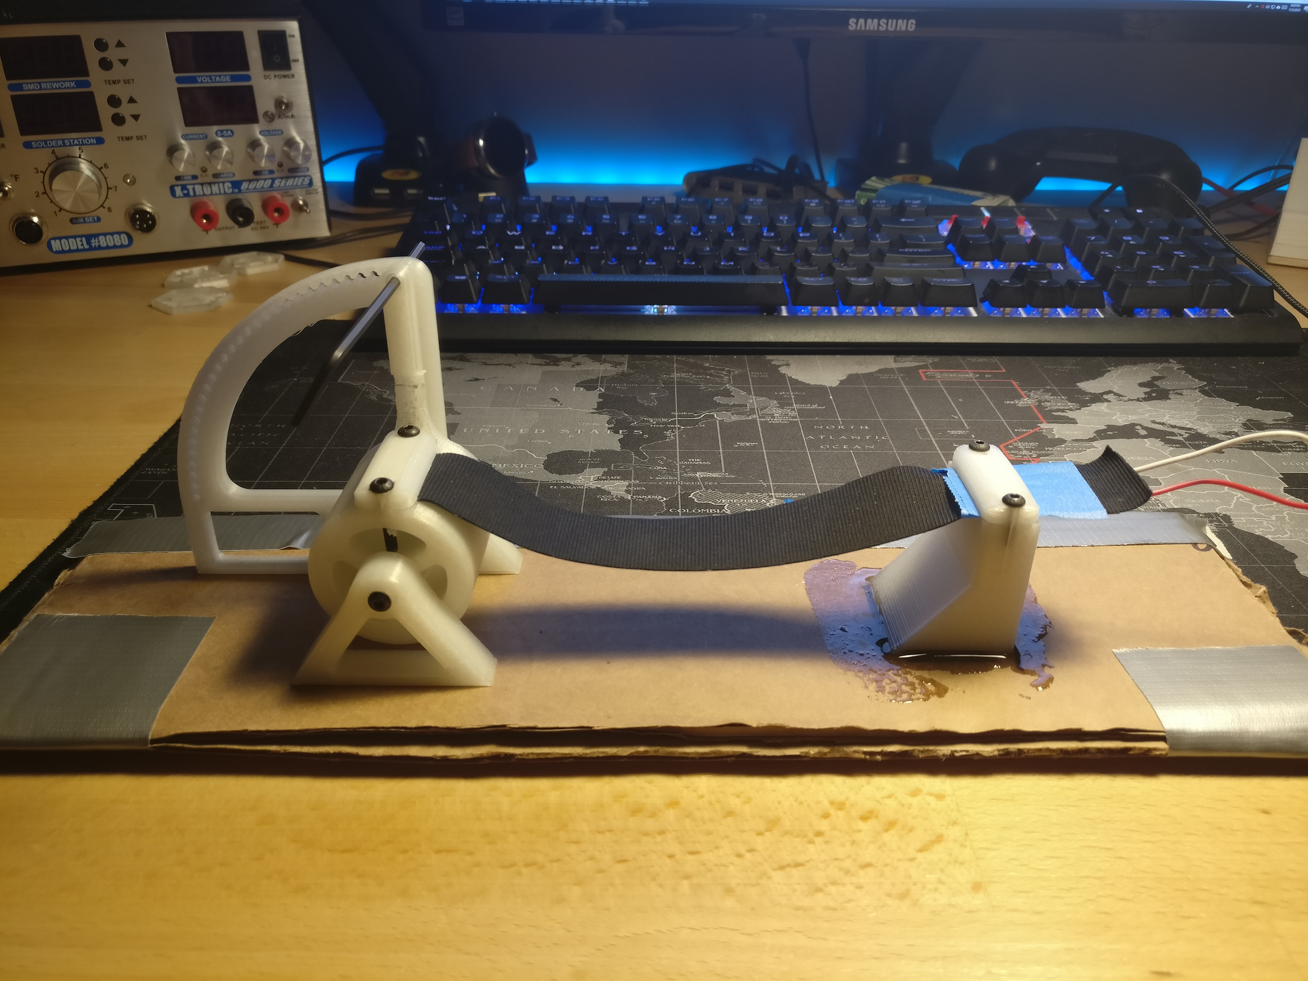

Figure 4.2. LiquidWire Test Apparatus

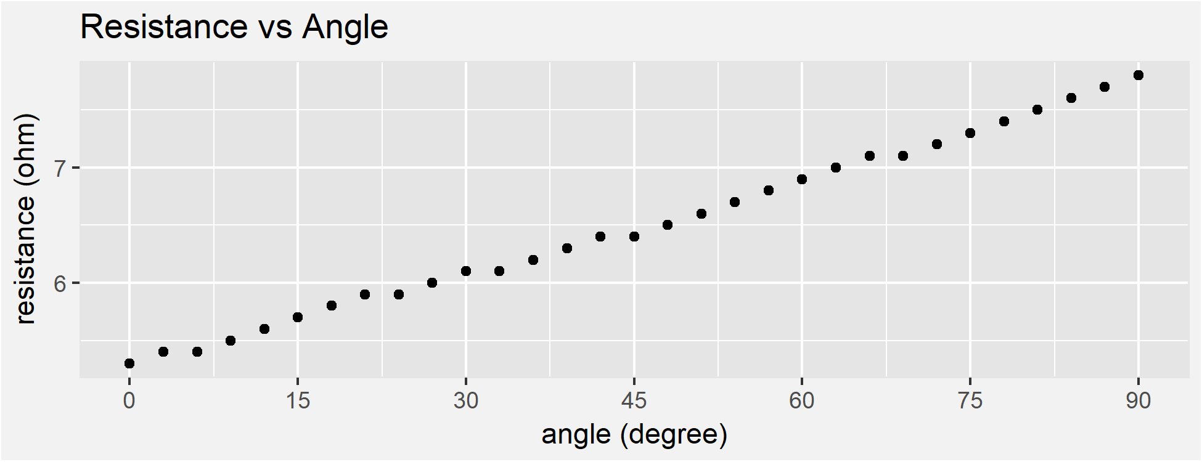

Figure 4.3. LiquidWire Test Measurements

### Pressure Sensor

Finally, a pressure sensor was connected to a multimeter and placed onto a 50 kg scale. A container of water was placed on top of the pressure sensor. A 3D-printer adapter focused the force from the container onto the small face of the pressure sensor. Water was added in 1 kg increments and the resistance was recorded after each increment. Figure 4.4 displays measured and expected resistance values.

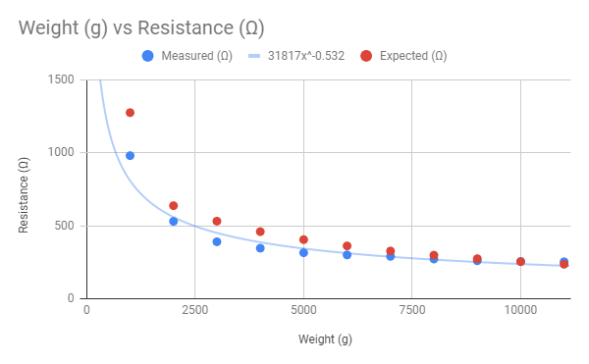

Figure 4.4. Pressure Sensor Test

## Wrist-Mounted Microcontroller Subsystem

### Battery

The battery was tested using an Arduino, a voltage divider, and a 36 Ω resistor. The battery was fully charged to 4.2 V and connected across the voltage divider. The Arduino was programmed to measure, interpret, and display battery voltage values every 30 seconds. The 36 Ω resistor was attached to the leads of the battery to simulate an average current draw of 0.1 A. Once the battery was depleted, the values were stored and plotted in a Voltage vs. Time graph seen in Figure 4.5.

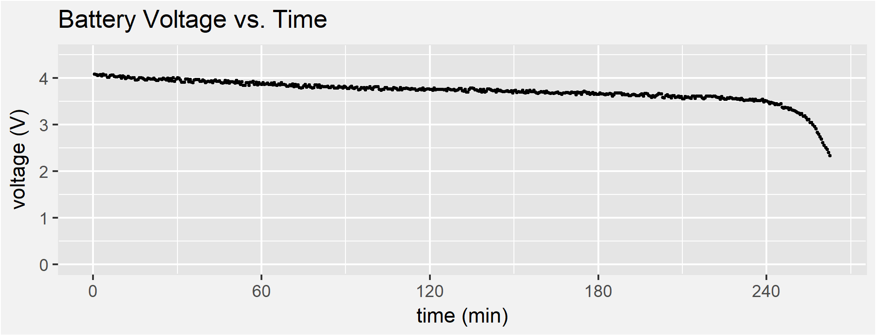

Figure 4.5. Battery Test

With an elapsed time of 4.375 hours and an average current draw of 0.103 A, the battery discharged 451.5 mAh over the duration of the test. Because the system will draw no more than 90 mA during peak usage, the battery is sufficient to meet the 5-hour runtime constraint.

### Sensor Polling

To ensure proper operation of the I2C bus, the first sensor test was to capture digital data transmission. The SDA and SCLK lines from the microcontroller were connected to the D0 and D1 inputs on a National Instruments Mixed Signal Oscilloscope. Next, a trigger was set for the oscilloscope output to trigger on the first data transfer. Figure 4.6 shows the oscilloscope output that depicts a write to the accelerometer with the appropriate read operation and response from the accelerometer.

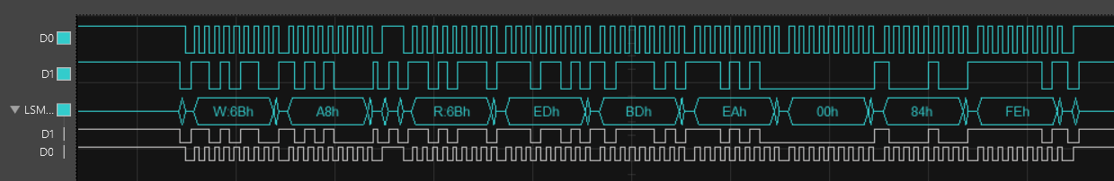

Figure 4.6. I2C Sensor Data Transfer

Next, two tests were employed to verify that the Cypress CYW20719 microcontroller and the selected sensor packages were capable of satisfying the Data Display constraint. The first of these tests began reading information from the sensors as fast as the microcontroller would allow and counted the total number of complete sensor frames read during a three second period. The second test, in comparison, measured the period of time required to read a constant number of sensor frames. These two tests yielded similar results and are shown in Table 4.3.

Table 4.3. Sensor Polling Tests

|  |  |  |
| --- | --- | --- |
| **Test** | **Minimum Required** | **Actual** |
| Total # of Readings in 3 seconds | >= 360 frames (120 frames/sec) | 4470 frames (1490 frames/sec) |
| Time to read 10000 sensor frames | <= 83.3 sec (120 frames/sec) | 7 seconds (1428.6 frames/sec) |

The slower measured polling rate, 1428.6 frames per second, is over 10 times faster than required by the Data Display constraint.

### Bluetooth Broadcast

The data throughput capabilities of the Bluetooth communication system were also tested against the Data Display constraints. For this test, the Cypress CYW20719 microcontroller was configured to transmit one 56-byte frame every 8 ms (125 Hz) to the coaching application. Upon reception of the frame by the coaching application, the current time was recorded. The time differences were computed for a few seconds of data. Figure 4.7 shows data frames being received in bursts by the coaching application. These bursts are caused by context switching and Bluetooth buffering of the operating system. However, these bursts do not affect the expected average throughput, which exceeds the design constraint of 120 Hz.

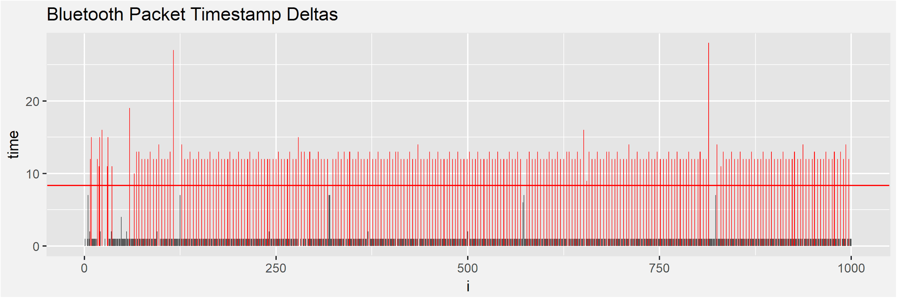Figure 4.7. Bluetooth Broadcast Test

### Hardware Footprint

The Golf Glove system main footprint consists of a Cypress CYW20719 microcontroller and four Analog to Digital Converters (ADC). These two components can be seen in Figure 4.8 and Figure 4.9. In Figure 4.8, the microcontroller and support circuitry are indicated by the red square, approximately 18 mm x 18 mm in size.

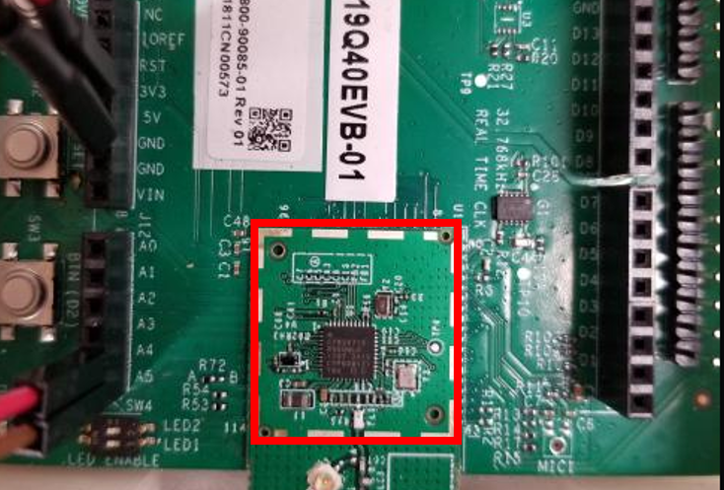

Figure 4.8. Microcontroller and Support Circuitry

In Figure 4.9, the four ADCs are indicated by the red squares. Each ADC is 3 mm x 4 mm.

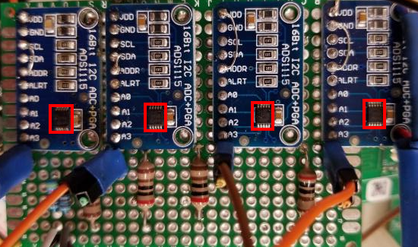

Figure 4.9

With a combined area of 372 mm2, the main components are well within our design constraint of 1935.48 mm2.

## Coaching Application Subsystem

### Bluetooth Reception

The Wireless Communication constraint requires that Golf Glove maintains Bluetooth communication at distances up to 9.15 meters. To test that the Golf Glove’s microcontroller satisfies this constraint, firmware that continuously broadcasts data was loaded onto the CYW20719 development board. Using Cypress’ CySmart application on a mobile phone, the RSSI of this broadcast was measured at 1 meter increments up to 15 meters. The graph of RSSI over distance is charted below in Figure 4.10. A signal strength of approximately -67 dBm was measured at 9.15 m.

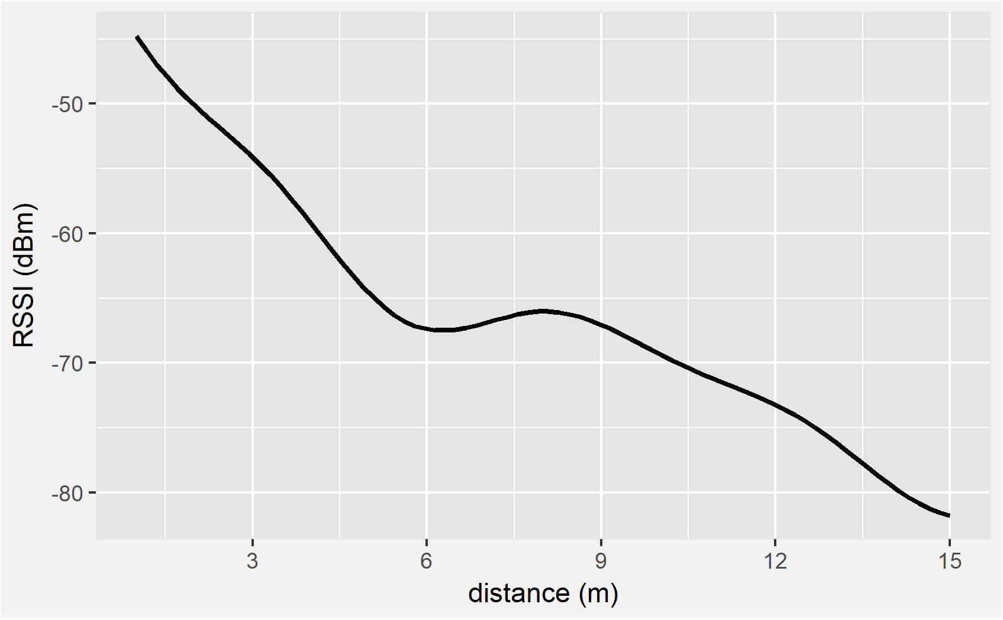

Figure 4.10. RSSI of Golf Glove Broadcast

### Database

On the backend of the coaching application, the data must be stored as quickly as it is received to prevent a buffer overflow. Following the Data Display constraint, the write performance of the database must be at least 120 Hz. To test its performance, the coaching application backend wrote 500 data frames to the SQLite database and recorded the timestamp deltas between inserts. All timestamp deltas satisfied the design constraint with an average write performance over 1.3 kHz. Figure 4.11 shows the timestamp deltas for each frame.

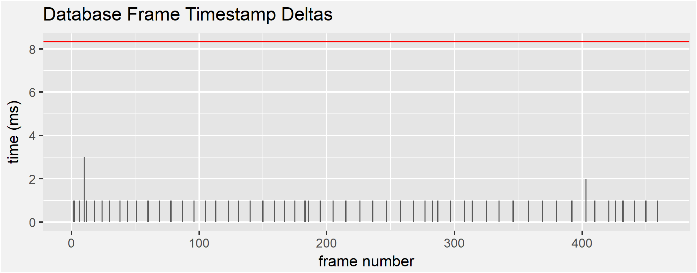

Figure 4.11. Frame-to-frame delay for 500 frames

### WebSocket Bandwidth

Meanwhile, the coaching application is also sending sensor frames to the frontend for display. The backend-to-frontend communication speed must exceed 120 Hz to support the Data Display constraint. To test the backend-to-frontend throughput, the backend sent 10,000 frames while the frontend recorded the time deltas upon reception of the frame. Figure 4.12 is a graph of the timestamp deltas. The values outlined in red do not meet the constraint delta. Similar to the Bluetooth Throughput test though, this is a consequence of protocol buffering. The application averages 0.6 ms (1.6 kHz) between each data frame, more than 10 times faster than the Data Display constraint.

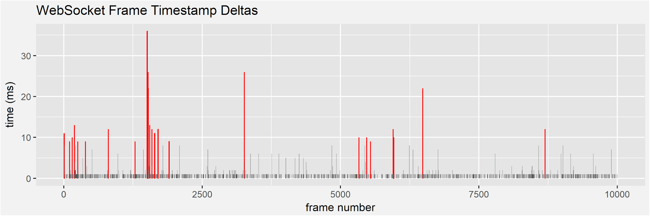

Figure 4.12. Frame-to-frame delay for 10,000 frames

## Integrated System

To complete the integrated system test, the wrist-mounted controller and the coaching application were first powered on. Next, the frontend instructed the backend to connect to the glove. The coaching application successfully connected to the Golf Glove at a distance of 10 m, satisfying the Wireless Communication constraint. Sensor data began streaming to the coaching application and the distance was increased to 48 m. During the test, the wrist-mounted controller remained connected and data was received on the front-end at a rate of at least 120 Hz, satisfying the Data Display constraint. Figure 4.13 and Figure 4.14 show the two components of the integrated system test.

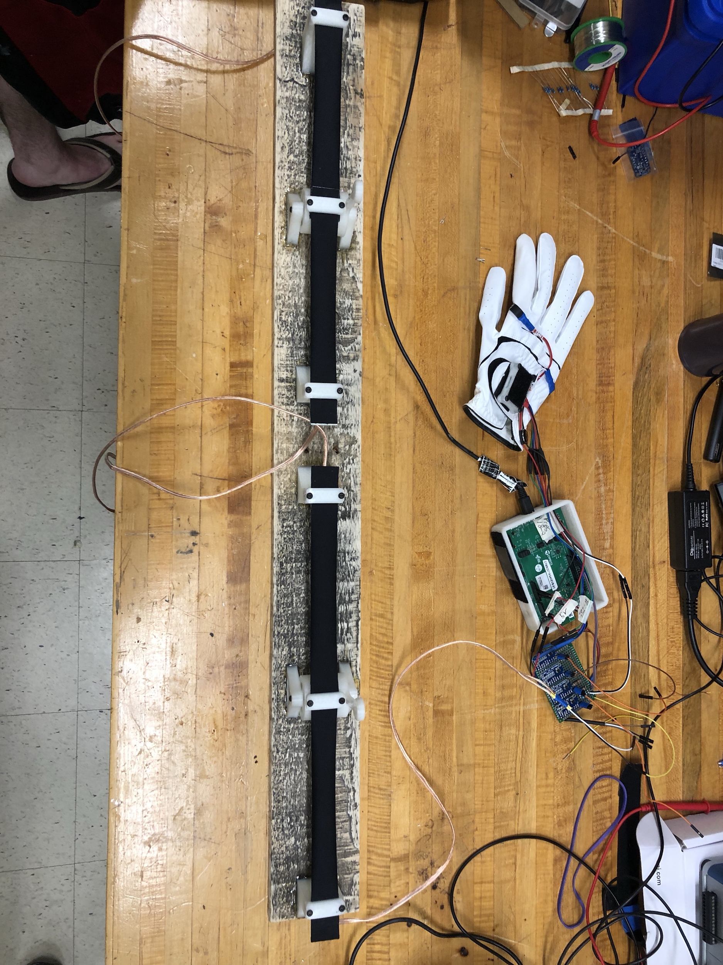

Figure 4.13. The glove and wrist-mounted controller

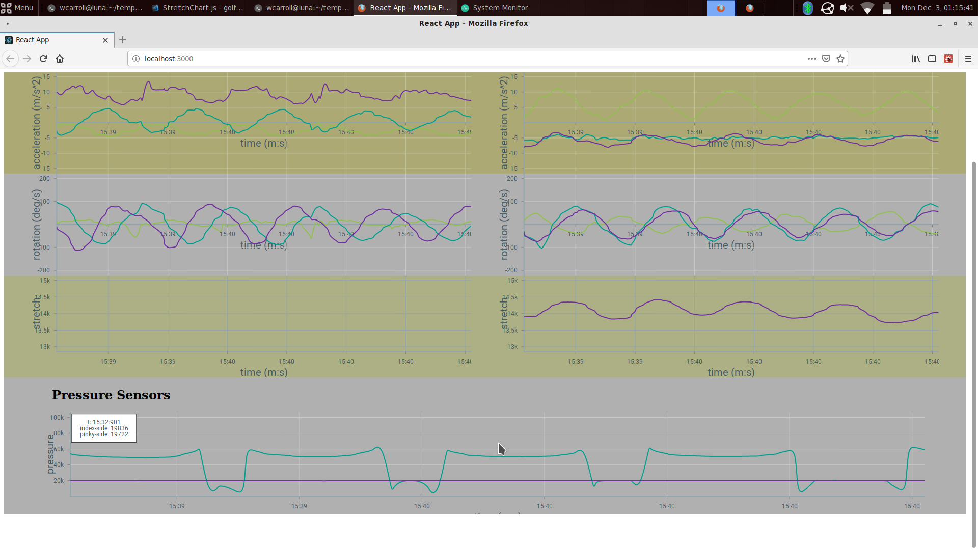

Figure 4.14. The coaching application display

Table 4.4 is a summary of the tests performed in Golf Glove’s evaluation. All tests passed and the system surpassed expectations.

Table 4.4: Summary of Tests

|  |  |
| --- | --- |
| **Technical Constraints** | **Test Results** |
| Hand Orientation | LiquidWire measured to have linear relationship between resistance and stretch, and accuracy measured within 3°.  Accelerometer and gyroscope measured to within 5% margin of error. |
| Wireless Communication | Wireless communication tested greater than 9.15 m. |
| Data Display | WebSockets tested to achieve greater than 120 Hz. |
| Unobtrusive | With a combined area of 3.72 cm2, the main components fit within an area of 19.35 cm2. |
| Portability | Battery was able to successfully supply enough capacity to power the device for a minimum of 5 hours. |

# SUMMARY AND FUTURE WORK

Throughout the design process, several problems were encountered. The problems that impacted the overall design are broken down by hardware, microcontroller, and coaching application sections. The current system records inertial, pressure, and stretch sensors. The design is currently limited by a cumbersome development board and by stretch sensor mounting difficulties. Future developments involving the   
Golf Glove system are discussed below.

## Hardware

The design initially used the integrated ADCs on the Cypress CYW20719 chip to poll the LiquidWire and pressure sensors. Due to the low change in resistance between the resting and stretched states of LiquidWire sensors, programmable gain amplifiers are necessary. To mitigate this problem, a Texas Instruments ADS1115 16-bit ADC was selected, predicting that it would allow four LiquidWire sensor readings simultaneously [39]. An issue arose from this solution: the ADS1115 contains only one internal ADC and switches between each analog input to complete conversions. This switching introduced a delay into the system that prevented the glove from reading all sensors simultaneously and was too slow to meet speed constraints. To solve this problem, three additional ADCs were added to the design.

More issues arose when upon mounting the stretch sensors on the wrist-mounted unit. LiquidWire’s stretch sensors must remain taut to output useful data to the glove. Any amount of slack in the sensors results in inaccurate and unusable resistance values. The initial design required attaching a strap on the wrist-mounted controller that could be tightened around the user’s wrist. When the user tightens the wrist unit such that the LiquidWire sensors are held taut, the tightened strap becomes uncomfortable and hinders the movement of the user. The design was modified to use a compression sleeve outfitted with internal rubber to provide adequate friction around the arm and keep the wrist-mounted controller stationary. Unfortunately, the sleeve did not prevent sliding of the wrist-mounted controller, loosened the LiquidWire, and compromised the data gathered from the sensors.

## Microcontroller

The Cypress CYW20719 microcontroller also required specific initialization for system data types and functions such as threading, timers, and queues. Initially, the team was unfamiliar with the syntax of using these functions. Cypress BLE chips are a relatively new product for the company and thus the documentation was lacking. After contacting Cypress Customer Support, the team was provided with example code explaining the syntax and functionality of these resources in the Real-Time Operating System.

Also, in order to conserve memory and processing power, the microcontroller doesn’t support floating-point arithmetic. Originally, the firmware intended to handle data parsing such as converting I2C reads from unsigned 8-bit integers to float objects; however, due to the restriction on the microcontroller, data parsing and formatting code was moved to the backend server of the coaching application.

## Coaching Application

During development, the team quickly found there were dependency issues preventing Bluetooth reception. The main issue occurred between *noble* (the Bluetooth framework chosen in the Approach) and *Electron* (the desktop environment used for rendering the GUI) were incompatible. To resolve thiscompatibility issue, the frontend GUI was changed to simply render the data in an internet browser. This change required creating an HTTP server to communicate the sensor frames from the backend to the frontend as this architecture requires two separate processes to run noble and the frontend rendering. WebSockets were chosen as the backend to frontend communication protocol to allow the backend to push data to the frontend without explicit requests for data from the frontend.

## Future Features

The Golf Glove firmware currently exposes raw sensor values to the coaching application in real-time mode, allowing for any application that can interface with BLE to connect and read sensor values. One future application could add an RFID sensor to the glove to detect golf club type with special RFID tags embedded in the club handle. Swing detection characteristics could be modified based on the club type to enable detection of different swing types such as chipping or putting.

The Golf Glove could also pair with a golf scoring application to record swings and golf scores in a database. Once many swings across multiple rounds of golf are recorded, a machine learning algorithm could be used to identify common characteristics of successful golf swing technique as well as common swing mistakes.

# ACKNOWLEDGEMENTS

The Golf Glove team would like to thank the following people:

Dr. John Ball, Assistant Professor in the Electrical and Computer Engineering Department at Mississippi State University, for providing initial introductions to the athletic department and his support of our project.

Tony Luczak, Graduate Research Assistant in the Recreational Sports Department at Mississippi State University, for providing expert advice in golf technique and business modeling.

# REFERENCES

[1] “History of Golf,” International Golf Federation. [Online]. Available: https://www.igfgolf.org/about-golf/history. [Accessed: 13-Sep-2018].

[2] R. Neal, “3D Kinematics and Kinetics of the Golf Swing,” *International Journal of Sport Biomechanics*, 1985. [Online]. Available: https://journals.humankinetics.com/doi/abs/10.1123/ijsb.1.3.221. [Accessed: 12-Sep-2018]

[3] A. Josephson, “The Economics of Golf,” *SmartAsset*, 2018. [Online]. Available: https://smartasset.com/retirement/the-economics-of-golf. [Accessed: 03-Sep-2018].

[4] “Pricing | Topgolf Allen,” *Topgolf*. [Online]. Available: https://topgolf.com/us/allen/pricing/. [Accessed: 04-Sep-2018].

[5] D. Johnson, “Best golf swing analyzers and shot trackers,” *Gadgets & Wearables*, 22-Apr-2018. [Online]. Available: https://gadgetsandwearables.com/2018/04/22/golf-swing-analyzer. [Accessed: 04-Sep-2018].

[6] “Standard Lengths,” *GolfWorks*. [Online]. Available: https://www.golfworks.com/images/art/StdLengths.pdf. [Accessed: 23-Sep-2018].

[7] “Driver-Head-Shapes and dimensions,” *Cast irons and Forged Irons, Manufacturing and Materials*. [Online]. Available: http://www.golfclub-technology.com/driver-head-shapes.html. [Accessed: 23-Sep-2018].

[8] “Average Golf Swing Speed Chart,” *Swing Man Golf – Blog*, 22-May-2018. [Online]. Available: http://www.swingmangolf.com/average-golf-swing-speed-chart-2/. [Accessed: 23-Sep-2018].

[9] J. Brauer, “Practical Tee Design,” *Golf Course Industry*, 08-Aug-2006. [Online]. Available: http://www.golfcourseindustry.com/article/practical-tee-design--design-column-/. [Accessed: 05-Oct-2018].

[10] C. Wang, “Hand tool handle design based on hand measurements,” MATEC Web Conf. [Online]. Available: https://www.matec-conferences.org/articles/matecconf/pdf/2017/33/matecconf_imeti2017_01044.pdf [Accessed: 24-Sep-2018].

[11] L. Vorvick, “Calculating body frame size: MedlinePlus Medical Encyclopedia Image,” *MedlinePlus*, 13-Jul-2016. [Online]. Available: https://medlineplus.gov/ency/imagepages/17182.htm. [Accessed: 24-Sep-2018].

[12] Cole, M. H., & Grimshaw, P. N. (2016). The biomechanics of the modern golf swing: implications for lower back injuries. *Sports Medicine*, *46*(3), 339-351.

[13] B. Kelley, “How Long Does It Take to Play a Round of Golf?,” *ThoughtCo*. [Online]. Available: https://www.thoughtco.com/time-it-takes-to-play-a-round-1560498. [Accessed: 24-Sep-2018].

[14] “Lithium Polymer Charging/Discharging & Safety Information,” *MaxAmps.com*. [Online]. Available: https://www.maxamps.com/lipo-care.php. [Accessed: 24-Sep-2018].

[15] Secure Systems and Technologies. (2018). *Ingress Protection*. [Online] Available at: http://sst.ws/downloads/Ingress-Protection-iss-4.pdf [Accessed 19 Sep. 2018].

[16] RoHSguide.com, RoHS Guide. http://www.rohsguide.com/rohs-faq.htm. [Accessed: 27-Sep-2018]

[17] Standard, I. E. C. 62209-2: Human Exposure to Radio Frequency Fields From Hand-Held and Body-Mounted Wireless Communication Devices Human Models. Instrumentation, and Procedures—Part, 1. [Accessed: 25-Sep-2018].

[18] Directive, R. (2003). Directive 2002/95/EC of the European Parliament and of the Council of 27 January 2003 on the restriction of the use of certain hazardous substances in electrical and electronic equipment. Official Journal of the European Union, 13, L37.

[19] Ahlbom, A., Bergqvist, U., Bernhardt, J. H., Cesarini, J. P., Grandolfo, M., Hietanen, M., ... & Swicord, M. L. (1998). Guidelines for limiting exposure to time-varying electric, magnetic, and electromagnetic fields (up to 300 GHz). Health physics, 74(4), 494-521.

[20] “Liquid Wire Technology,” Liquid Wire. [Online]. Available: https://liquidwire.io/technology. [Accessed: 26-Oct-2018].

[21] “Hand Grip Strength: age and gender stratified normative data in a population-based study,” BMC Res Notes, Apr. 2011.

[22] E. Komi, J. Roberts, and S. Rothberg, “Measurement and analysis of grip force during a golf shot,” Proceedings of the Institution of Mechanical Engineers Part P Journal of Sports Engineering and Technology, Jun. 2008.

[23] “FS R ® 400 Series Data Sheet,” 2017. [Online]. Available: https://cdn2.hubspot.net/hubfs/3899023/Interlinkelectronics November2017/Docs/Datasheet_FSR.pdf. [Accessed: 25-Oct-2018].

[24] Adafruit Industries, “Pressure-Sensitive Conductive Sheet (Velostat/Linqstat),” adafruit industries blog RSS. [Online]. Available: https://www.adafruit.com/product/1361. [Accessed: 26-Oct-2018].

[25] “Acceleration,” Quintic Sports. [Online]. Available: https://www.quinticsports.com/wp-content/uploads/2016/06/Case-Study-12-Acceleration.pdf. [Accessed: 25-Oct-2018].

[26] Loopy, “Golf Swing Sequence and Timing – The Downswing,” Golf Loopy - Play Your Golf Like a Champion, 14-Oct-2015. [Online]. Available: http://www.golfloopy.com/golf-swing-sequence-and-timing-downswing/. [Accessed: 25-Oct-2018].

[27] “LSM9DS1 Datasheet.” [Online]. Available: https://www.st.com/resource/en/datasheet/lsm9ds1.pdf. [Accessed: 25-Oct-2018].

[28] “Bosch Sensortec BMX055 Datasheet.” [Online]. Available: https://ae-bst.resource.bosch.com/media/_tech/media/datasheets/BST-BMX055-DS000-02.pdf. [Accessed: 25-Oct-2018].

[29] “mCube MC6479 Preliminary Datasheet.” [Online]. Available: https://www.mouser.com/datasheet/2/693/MC6470-Preliminary-Datasheet-APS-048-0033v1.6--1489118.pdf. [Accessed: 25-Oct-2018].

[30] “Enhanced Low Power, BR/EDR/BLE Bluetooth 5.0 SOC Datasheet,” 12-Jul-2018. [Online]. Available: http://www.cypress.com/file/414181/download. [Accessed: 25-Oct-2018].

[31] “Bluetooth® Low Energy (BLE) SoC.” [Online]. Available: http://ww1.microchip.com/downloads/en/DeviceDoc/IS1870_71-Bluetooth-Low-Energy-BLE-SoC-DS60001371E.pdf. [Accessed: 25-Oct-2018].

[32] “Li-Polymer Battery Technology Specification,” Adafruit Industries. [Online]. Available: https://cdn-shop.adafruit.com/product-files/1578/C1854 PKCell Datasheet Li-Polymer 503035 500mAh 3.7V with PCM.pdf. [Accessed: 25-Oct-2018].

[33] “Robot?,” Newegg- Computer Parts, Laptops, Electronics, HDTVs, Digital Cameras and More![Online]. Available: https://www.newegg.com/Product/Product.aspx?Item=9SIA4SR6YH7231&ignorebbr=1&nm_mc=KNC-GoogleMKP-PC&cm_mmc=KNC-GoogleMKP-PC-_-pla-_-AT - Batteries & Accessories - Replacement-_-9SIA4SR6YH7231&gclid=Cj0KCQjw08XeBRC0ARIsAP_gaQBDs4SNdrioxPFeVZ5y1T08FjWVodO-wwc_uowzROIrS8EiuxSbWOAaAlTUEALw_wcB&gclsrc=aw.ds. [Accessed: 26-Oct-2018].

[34] “MX2400 Alkaline-Manganese Dioxide Battery Datasheet.” [Online]. Available: http://professional.duracell.com/downloads/datasheets/product/Ultra Power/Ultra-Power_AAA_MX2400.pdf. [Accessed: 25-Oct-2018].

[35] “Manganese Dioxide Lithium Coin Batteries: Individual Specifications.” [Online]. Available: https://www.alliedelec.com/m/d/6ec5c9a8833414eb34f877f612fc890f.pdf. [Accessed: 25-Oct-2018].

[36] “noble/noble,” GitHub, 08-Jun-2018. [Online]. Available: https://github.com/noble/noble. [Accessed: 26-Sep-2018].

[37] “Electron,” Electron. [Online]. Available: https://electronjs.org/. [Accessed: 26-Sep-2018].

[38] “React – A JavaScript library for building user interfaces,” React. [Online]. Available: https://reactjs.org/. [Accessed: 26-Sep-2018].

[39] “ADS1115 Analog to Digital Converter.” [Online]. Available: http://www.ti.com/lit/ds/symlink/ads1115.pdf [Accessed: 5-Dec-2018].

[40] “SWINGURU PRO GOLF / 1-Year,” *Swinguru | Markerless 3D Swing Analyzers*. [Online]. Available: https://www.swinguru.com/product/swinguru-pro-1-year/. [Accessed: 06-Dec-2018].

[41] “Products Archive,” *StretchSense*. [Online]. Available: https://www.stretchsense.com/shop/. [Accessed: 06-Dec-2018].

# APPENDIX: PRODUCT SPECIFICATION AND SCHEMATIC

